**Exercise: Edit a website using a browser developer tools**

**Introduction**

In this exercise, you will practice editing an HTML page using the developer tools.

**Goal**

* Edit the HTML document using the developer tools in your browser.

**Objectives**

* Change the text of Our Menu to Little Lemon Menu.

**Instructions**

**Step 1:** Download the following file on your local system.

*Note: If you have completed the exercise Examine the Page, you can skip steps 1 and 2 as the file contains the same assets from that exercise.*

**Step 2:** Unzip the file.

On Windows, open your Downloads folder, right-click the file *examine_the_page.zip* and select Extract All.

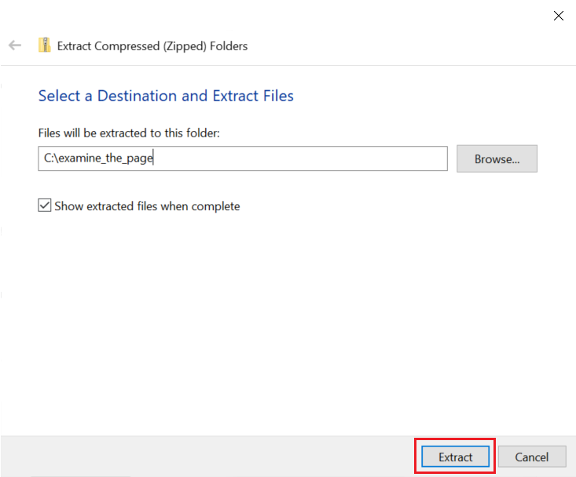

On Mac, open your Downloads folder and double click the file *examine_the_page.zip*.

Once unzipped, there will be a folder named *examine_the_page*.

**Step 3:** Open the index.html file in your local browser for preview. Verify that it looks like this:

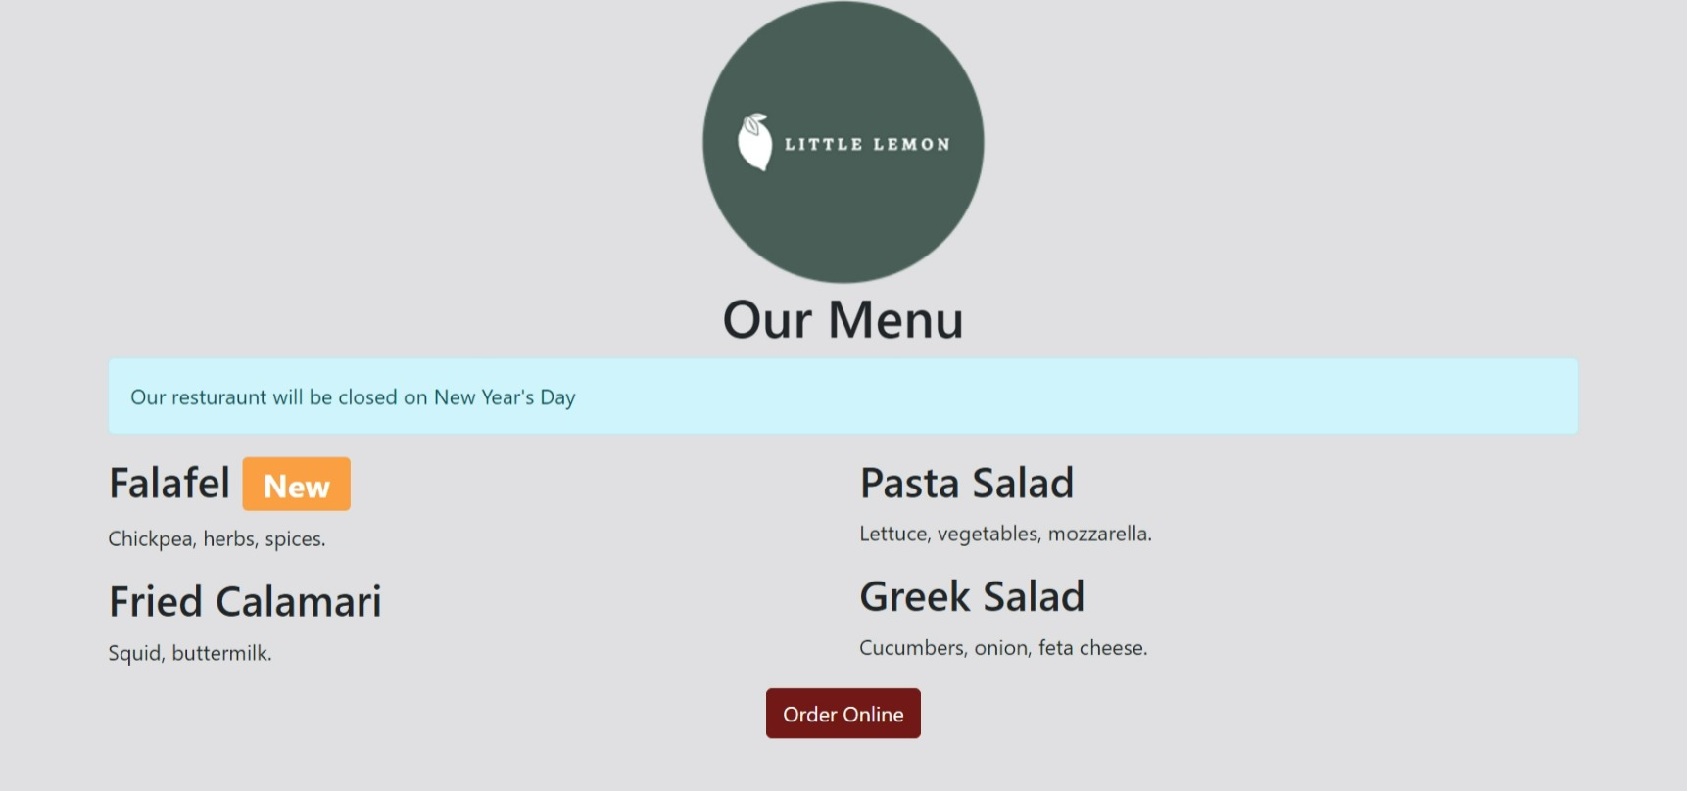

**Step 4:** Right-click the *Our Menu* text and select *Inspect* or *Inspect Element.*

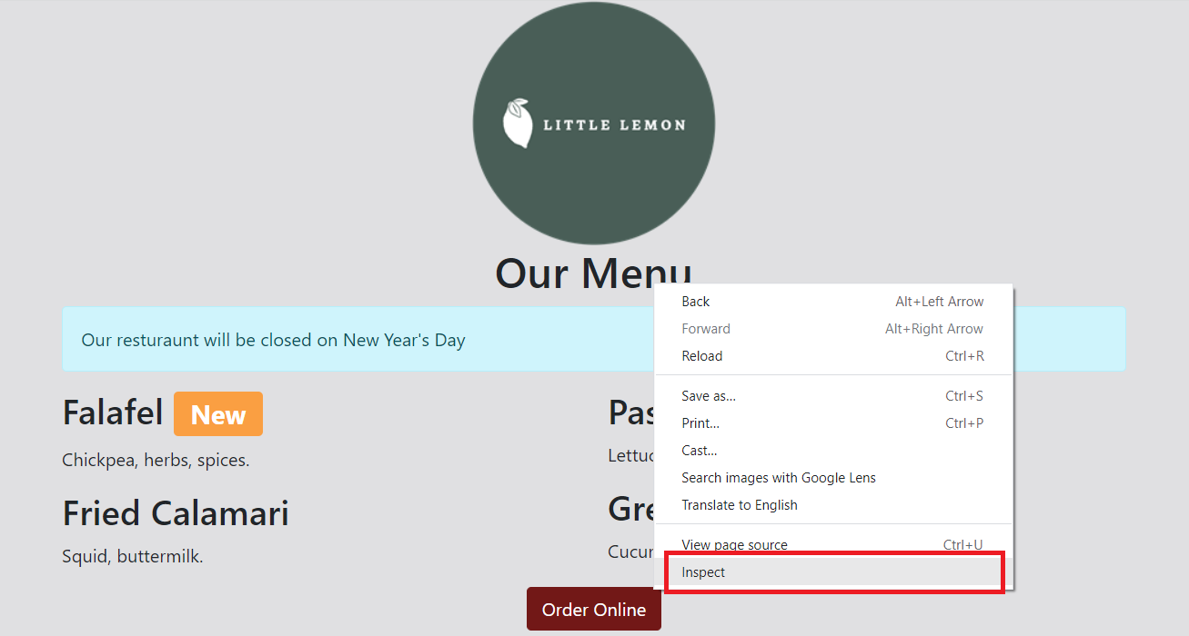

**Step 5:** Double-click the *Our Menu* text in the Elements tab of the developer tools panel.

**Step 6:** Change the text to *Little Lemon Menu*.

**Step 7:** Close the developer tools.

**Step 8:** Verify that the text has changed on the web page.

**Tips**

* If you get stuck, close the developer tools and start from the beginning.
* Review the lesson *Developer Tools*.